Website Design Task 2 synoptic

# **A computer screen with a black text AI-generated content may be incorrect.Low-fi wireframes**

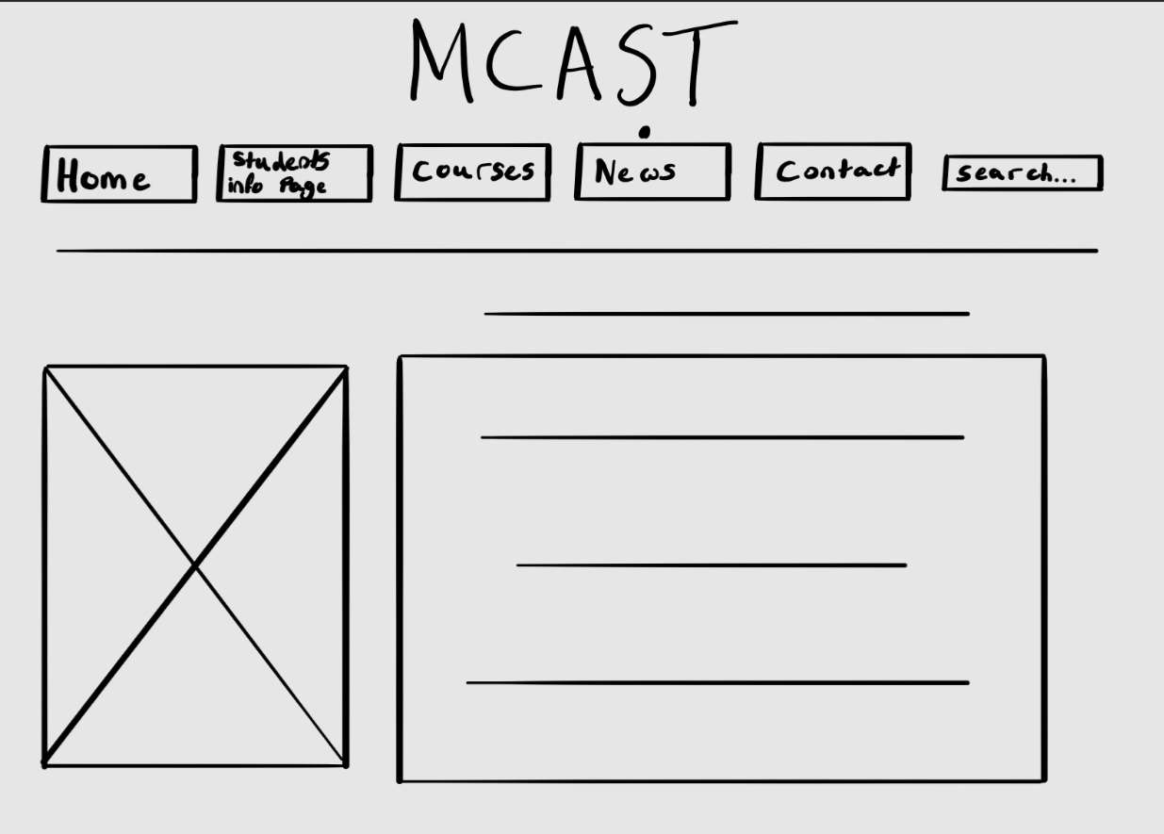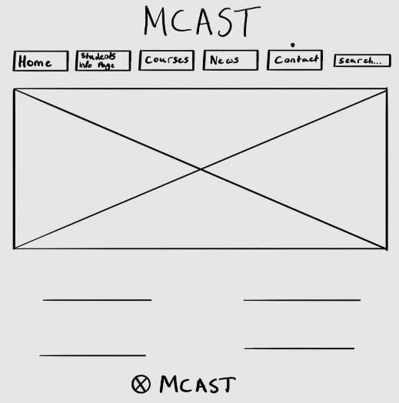

## **A computer with a screen showing several images AI-generated content may be incorrect.High- fidelity wireframe/mock-up**

# **A group of grey and black colors AI-generated content may be incorrect.Colour Palette: Font and its use**:

# **A close up of text AI-generated content may be incorrect.Button and link style/ Iconography**: